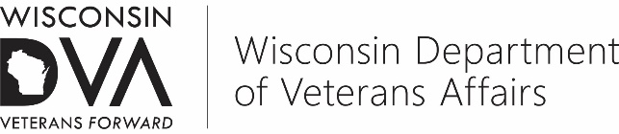  Wis. Stats. Chapter 45 |  | 201 West Washington Avenue, P.O. Box 7843, Madison, WI 53707-7843  (608) 266-1311 | 1-800-WIS-VETS (947-8387)
 | APPLICATION FOR AMERICAN INDIAN VETERANS SERVICE GRANT
The information requested on this form is authorized for collection by Ch. 45, Wis. Stats. and VA 15, Wis. Adm. Code. The information collected is used to determine eligibility for programs administered by the department. Completion of this form is voluntary; however, failure to furnish the requested information may result in denial of eligibility for programs. Personally identifiable information collected on this form is not likely to be used for any other purpose.
This department does not discriminate on the basis of race, color, national origin, sex, religion, age, or disability in employment or provision of services.

Pursuant to Wis. Stats. § 45.82(4), |  |  |  |  |  | Tribe, hereby applies
for an American Indian Veterans Service Grant for the Fiscal Year beginning |  |  |  |  | January 1, 2019 |  | , and ending
December 31, 2019 | , for the purpose of extending and strengthening service of veterans of this tribe.
Personnel now employed, with present and proposed monthly salary, by this tribe to operate the Tribal Veterans Service
Office (TVSO) are:

Job Title
Tribal Veterans Service Officer (TVSO)
Choose one: Full-Time or Part-time
Others: (Insert Tribal Job Title)

The application is hereby agreed to by the Tribal Council of |  | Nation to
include all of the following conditions:

1. The TVSO shall be appointed in accordance with VA 15.03.

2. The Tribal Veterans Service Office will be maintained, open and staffed during normal tribal or band office hours; and

3. The TVSO will be authorized to attend Tribal Veterans Service conferences, institutes and workshops and training sessions conducted by the Wisconsin Department of Veterans Affairs or the U.S. Department of Veterans Affairs, as a regular part of his or her duties and will be provided equitable allowance or reimbursement for all necessary travel required in veterans service at the same rate all other employees are paid.

4. The grant received will not be allocated “for use by another tribal department nor may the tribe reduce funding to a tribal veterans service office based upon receipt of a grant.” Grant funds shall be maintained in a separate account subject to audit by Wisconsin Department of Veteran Affairs.

Tribal Veterans Service Officer |  | Tribal President/Chairperson  Or Designated Tribal Council Official
Please submit with this application a certified copy of the budget adopted by the governing body of the tribe or band for the tribal veterans service office operation for calendar year 2019 to include the proposed use of the fiscal year 2019 tribal veterans service grant (sample format attached), federal benefits service delivery report, and statement in the application cover letter which addresses success in meeting the previous year goals and objectives and include the goals and objectives for this grant period.

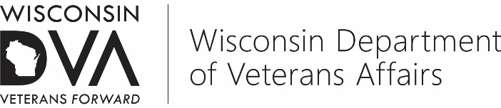  Wis. Stats. Chapter 45 | 201 West Washington Avenue, P.O. Box 7843, Madison, WI 53707-7843  (608) 266-1311 | 1-800-WIS-VETS (947-8387)
GRANT AGREEMENT
BETWEEN THE STATE OF WISCONSIN, DEPARTMENT OF VETERANS AFFAIRS
AND TRIBAL VETERANS SERVICE OFFICER

This agreement is made and entered into effective this |  |  |  |  |  |  |  | 1st |  |  | day of |  |  | January |  |  |  | , | 2019 | ,
between the Department of Veterans Affairs (hereinafter referred to as the “Department”), the
 |  |  |  | Nation and the |  |  |  |  |  |  |  |  |  |  |  | Nation Tribal Veterans Service
Officer (hereinafter referred to as the TVSO).
The TVSO shall file a grant application with the Department of Veterans Affairs for the current fiscal year, which shall include a certified copy of the budget adopted by the governing body of the tribe or band for the tribal veterans service office operation for fiscal year _2019________ to include the proposed use of the TVSO grant, and a federal benefits service delivery report for the preceding calendar year.

The attached statement of goals and objectives for January 1, 2019 through December 31, 2019is a part of this agreement. The TVSO agrees to provide the Department with relevant information pertaining to the achievement of those goals and objectives.
The provision of services to former military personnel, dependents and survivors covered by this agreement shall be from
January 1, 2019 |  |  | through |  | December 31, 2019 |  |  |  |  |  |  |  | .
The Department shall pay the TVSO’s tribe the entire grant to which the TVSO’s tribe is entitled under Wis. Stats. § 45.82(4) provided the TVSO and the TVSO’s tribe have abided by the terms and conditions of this agreement.
STATE OF WISCONSIN |  |  |  |  |  |  |  |  |  | NATION OF
DEPARTMENT OF VETERANS AFFAIRS |  |  |  |  |  |  |  |  |  | STATE OF WISCONSIN
BY: |  |  |  |  |  |  |  |  |  | BY:
 | James Bond
 | Division Administrator
 | Division of Veterans Benefits
 |  |  |  |  |  |  |  |  |  |  |  | TVSO

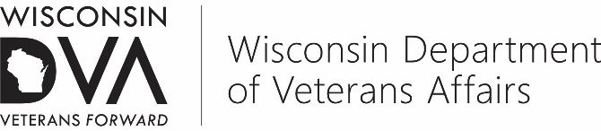  Wis. Stats. Chapter 45 |  |  |  |  | 201 West Washington Avenue, P.O. Box 7843, Madison, WI 53707-7843  (608) 266-1311 | 1-800-WIS-VETS (947-8387)
AMERICAN INDIAN VETERANS SERVICE GRANT — FEDERAL BENEFITS REPORT
The information requested on this form is authorized for collection by Ch. 45, Wis. Stats. and VA 15, Wis. Adm. Code. The information collected is used to determine eligibility for programs administered by the department. Completion of this form is voluntary; however, failure to furnish the requested information may result in denial of eligibility for programs. Personally identifiable information collected on this form is not likely to be used for any other purpose.

This department does not discriminate on the basis of race, color, national origin, sex, religion, age, or disability in employment or provision of services.
Report for calendar Year |  |  | 2018 |  |  | ; FOR |  |  | TVSO
From | January 1, 2018 | , to |  | December 31, 2018

FEDERAL BENEFITS
 | ACTIVITY | NUMBER | COMMENTS
1. | Power of Attorney Indicate the number of new VA Form 21-22s submitted to WDVA/Other VSOs for representation | /
2. | Disability Compensation Indicate the number of new VA Form 21-526s, reconsiderations VA 21-526 or 21-527 or other communications submitted for compensation benefits to WDVA/VA or other VSO
3. | Pension Indicate the number of VA Form 21-527s or other communications submitted for veterans Pension benefits to WDVA/VA or other VSO
4. | Medical Expenses for Pension Indicate the number of VA Form 21p-8416s submitted for Unreimbursed Medical Expenses for pension and death pention to WDVA/VA or other VSO
5. | Loan Guaranty Indicate the number of Federal Home Loan applications submitted
6. | Educational Indicate the number of Federal Educational benefit applications submitted
7. | Vocational Rehabilitation Indicate the number of Federal VocRehab applications submitted
8. | Medical Indicate the number of VA Form 1010EZ forms submitted for enrollment into VA Healthcare
9. | USDVA Notices of Disagreement Indicate the number of Notice of Disagreements, VA Form 21-0958, DRO Request forms submitted to WDVA/VA or other VSO
10. | USDVA Waiver Requests Indicate the number of requests for waivers of Federal benefits regulations submitted
11. | BVA Appeals Indicate the number of VA Form 9s submitted to WDVA/VA or other VSO
12. | Insurance Indicate the number of applications for VA Insurance programs submitted
13. | Burial Allowances Indicate the number of applications for VA Burial Allowance submitted
14. | Flag Applications Indicate the number of applications submitted for Burial Flags
15. | Marker Applications Indicate the number of applications submitted for Burial Markers
16. | DIC Indicate the number of applications for Dependency and Indemnity Compensation, VA Form 21-534, submitted to WDVA/VA or other VSO
17. | Survivor’s Pension Indicate the number of applications for VA Death Pension, VA Form 21-534, submitted to WDVA/VA or other VSO
18. | Discharge Correction Indicate the number of applications for discharge upgrades submitted
19. | Miscellaneous Indicate the number of applications for other federal benefits, not listed, submitted by your office. Include types in comments.

AMERICAN INDIAN VETERANS SERVICE GRANT

PROPOSED BUDGET FORMAT

TVSO GRANT 2019

[Tribal Name] TRIBE

Goals and Objectives |  |  |  |  | Proposed Budget |  | Time  Frame
Office Expenses (Related to TVSO Grant Administration Only) |  |  |  |  | $ 1,000.00 |  | Ongoing
Advertising of Veterans Programs and TVSO Office |  |  |  |  | $ 500.00 |  | Monthly
WDVA Targeted Initiative: Outreach to include: |  |  |  |  | $ 1,500.00 |  | Ongoing
 | Promotion of WDVA benefits, programs and services
 | Veterans Benefits and Job Fairs
 | Homeless Veterans Initiative
 | Education Benefits
WDVA or VA Conference and Training Cost |  |  |  |  | $ 800.00 |  | Spring, Fall
Develop relationships with community agencies offering benefits needed by veterans (employment, rehabilitation, counseling, emergency needs)  Publicity of Federal Compensation and Pension Benefits |  |  |  |  | $ 2,000.00  $ 1,000.00 |  | Ongoing
TOTAL |  |  |  |  | $ 6,800.00

