Applies To:
- Animal-Assisted Therapy volunteer handlers, to include: Activity staff, Volunteers, WVH staff, Family and Friends of WVH Members.
NOTE: Check for allergens to animals before exposing a Member to an animal as part of this program.

Related Documents:

Delta Therapy Dogs · Delta Society

http://www.avma.org/issues/policy/animal_assisted_activity.asp
- https://www.avma.org/KB/Policies/Pages/Animal-Assisted-Interventions-Guidelines.aspx
- http://www.tdi-dog.org/

Definitions:
- Animal-Assisted Therapy (AAT) – Animal-assisted therapy is a goal-directed intervention in which an animal that meets specific criteria is an integral part of the treatment process. These programs are usually directed and delivered by human health or human services professionals with specialized expertise and within the scope of practice of their profession. Animal-assisted therapy is designed to improve human physical, social, emotional, and cognitive (e.g., thinking and intellectual skills) function and animals may be formally included in activities such as physical, occupational, or speech therapy. Therapy programs are provided in a variety of settings and may involve individuals or groups. In AAT, specified goals and objectives are determined for each patient and their progress is evaluated and documented.
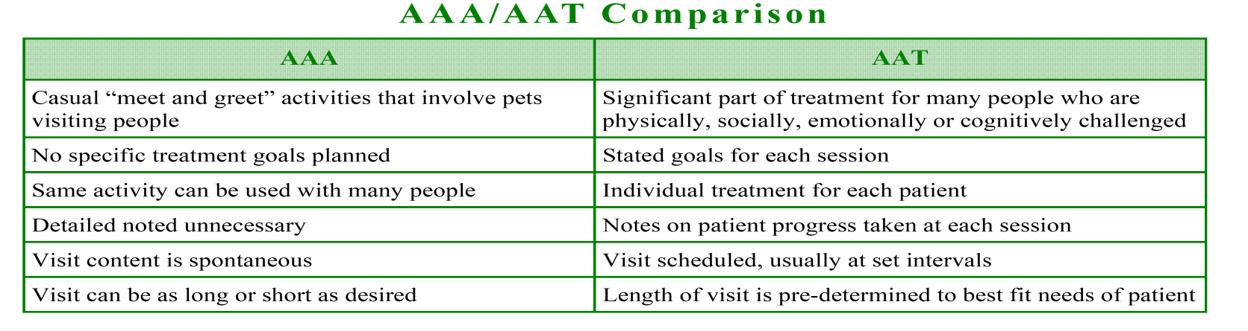
- Animal-Assisted Activities (AAA) – Animal-assisted activities provide opportunities for motivation, education, or recreation to enhance quality of life. Animal-assisted activities are delivered in various environments by specially trained professionals, paraprofessionals, and volunteers in association with animals that meet specific criteria. Included are "meet and greet" activities that involve pets and their handlers visiting people on a scheduled or spontaneous basis, as well as programs permitting family members or friends of facility residents to bring their own pet or the resident's pet for a visit. The same activity may be repeated with many individuals or be conducted in groups; unlike therapy programs, they are not tailored to a particular person or medical condition. Visit content is spontaneous and visits are as long or as short as necessary.

Policy:

Requirements for Animal-assisted Therapy Volunteers:
- Certifications or re-certifications must have occurred within three (3) years of application to Wisconsin Veterans Home Animal-assisted Therapy Volunteer Program, or documentation must be provided from organizations where the animal is currently providing therapy.
- A completed and signed Wisconsin Veterans Home WDVA 4037 Animal-Assisted Activity/Therapy Health Assessment Form must be provided annually. Veterinarian must document that the animal is current for the appropriate vaccinations and following a parasite prevention program.
- Handler must follow all procedures and policies specified for Wisconsin Veterans Home volunteers, including:
  - Application including background check.
  - Interview (including the animal).
  - Reference check.
  - Orientation to volunteering.
  - Orientation to each department visited by the handler and animal.
  - Sign-in and out for each visit.
  - Display proper Wisconsin Veterans Home volunteer identification badge.
- Documentation must be provided showing that the animal and handler have attended and achieved certification for animal-assisted therapy. Examples of programs include: Animal Protective Association, Delta Society, Humane Society, Support Dogs’ Touch Program, Therapy Dogs, Inc, or Therapy Dogs International.
- Documentation must be provided showing that the animal is current for the following vaccinations:
  - DHLPP (Distemper, Hepatitis, Leptospirosis, Para-Influenza, Parvo Virus, Carona Virus)
  - Rabies
  - Bordetella (only if dog is boarded)
- Documentation must also be provided showing that the animal is following a regimen for heartworm and flea prevention.
- Pets other than dogs or cats must be approved by Administration prior to visit.
Requirements for Animal-assisted Activities Volunteers:
- A completed and signed Wisconsin Veterans Home WDVA 4037 Animal-Assisted Activity/Therapy Health Assessment Form must be provided annually. Veterinarian must document that the animal is current for the appropriate vaccinations and following a parasite prevention program.
- Handler must follow all procedures and policies specified for Wisconsin Veterans Home volunteers, including:
  - Application including background check.
  - Interview (including the animal).
  - Reference check.
  - Orientation to volunteering.
  - Orientation to each department visited by the handler and animal.
  - Sign-in and out for each visit.
  - Display proper Wisconsin Veterans Home volunteer identification badge.

- Documentation must be provided showing that the animal is current for the following vaccinations:
  - DHLPP (Distemper, Hepatitis, Leptospirosis, Para-Influenza, Parvo Virus, Carona Virus)
  - Rabies
  - Bordetella. (Only required if dog is boarded)
- Documentation must also be provided showing that the animal is following a regimen for heartworm and flea prevention.
- Pets other than dogs or cats must be approved by Administration prior to visit.
Guidelines:
- Animals must be appropriately controlled at all times in a manner which protects the well-being of both members and animals.
  - Animals are not allowed in areas while food is being prepared, served or stored.
  - Animals are not allowed on furniture in common areas of the facility. Animals may be allowed on furniture in member’s rooms, at the discretion of the member.
  - Unusual or exotic animals (any pet other than dogs or cats,) must be approved by Administration in advance of visit.
  - Animals must be housebroken or properly contained. Animal handlers will provide clean-up materials and dispose of waste in outdoor receptacles.
  - Animal visits shall only be allowed between 9:00 AM and 7:00 PM.
  - If animals become stressed and/or unruly, or procedures are not being followed, the animal handler will be asked to remove the animal from WVH grounds.
  - Members may request not to participate in Animal-Assisted Therapy.
  - Animal-Assisted Therapy/Activity handlers will read and sign the WDVA 4709 Pet Guideline Agreement. Completed forms will be filed with the handler’s volunteer application materials.
  - Animal Assisted Therapy / Activity handlers will read and sign the Release and Waiver of Liability and Indemnity Agreement WDVA 4036
  - Family Pet handlers will read and sign the WDVA 4709 Pet Guideline Agreement
  - Family Pet handlers will read and sign the Release and Waiver of Liability and Indemnity Agreement WDVA 4035
  - Approved animals will be issued a tag to be worn on the collar or a card to be presented to staff by the handler. Unapproved animals will not be allowed in any buildings.
  - Upon completion of visit, handler or staff will assist member with hand washing and sanitation.

Liability: WDVA 4036
- The animal handler shall be liable for the full amount of damages caused by the animal injuring or causing injury to a person, or property when visiting a Wisconsin Veterans Homes facility. In case of a dog, the animal handler’s liability and penalties shall be those under Sec. 174.02, Wisconsin Statutes.
- The animal handler shall indemnify and hold harmless the State of Wisconsin, the Department of Veteran Affairs, and their respective officers, directors, employees and agents from and against any and all liabilities, damages or claims that may arise in connection with any animal-assisted therapy or animal-assisted activities conducted in the Wisconsin Veterans Home.

